2022 - Utah County I Voted Sticker Contest
The Utah County Elections Division would like to invite the secondary school age students to participate in our “I Voted Sticker” contest. We ran this event for the first-time last year with great success; we enjoyed looking at all the entries. We would love to have even more submissions this year, so we would invite you to get the word out and encourage students to participate!
We want to have a sticker that symbolizes Utah County. The winner of the contest will have their I Voted Sticker distributed in this year’s 2022 General Election ballots.
The sticker will be round and 2” x 2” in diameter. We will be judging the stickers on original design and relevance to Utah County.
Please complete the Contest Entry form and attach it to your I Voted Sticker entry. The I Voted Sticker entry can be submitted by one of the following methods:
- Electronically via email to elections@utahcounty.gov
- By Mail to Utah County Elections, 100 E Center St, Ste. 3100, Provo, UT 84604
- In person at Utah County Elections, 100 E Center St, Ste. 3100, Provo, UT 84604
All submissions must be received in the Utah County Elections Office by Tuesday, March 1, 2022. Winners will be announced the week of March 15.
Click on this link for examples of I Voted Stickers from each state. https://www.cnn.com/interactive/2020/11/politics/vote-stickers-trnd/
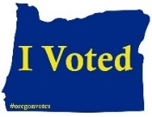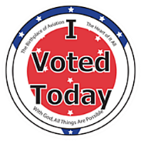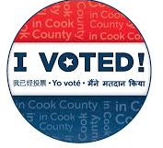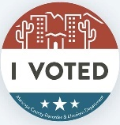

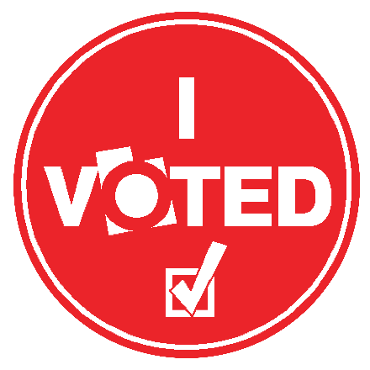
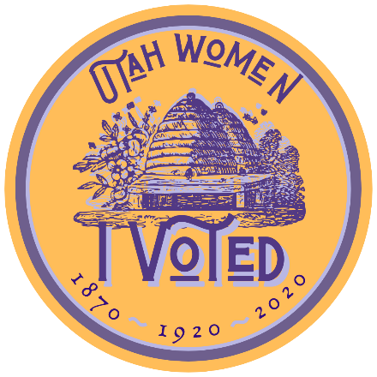
Actual size 2”x2”

Please call our office at (801) 851-8128 if you have any questions regarding this contest. We look forward to your seeing your creative designs!

